Week 3: Money and Macroeconomic Stability

* 1990 Soviet Union broke up 1978 China first reform: rural infrastructure, 1994 second reform: SOEs privatized
* Second reform had bigger impact
* Second reform created three economic entities: Firms, Government and Households
* 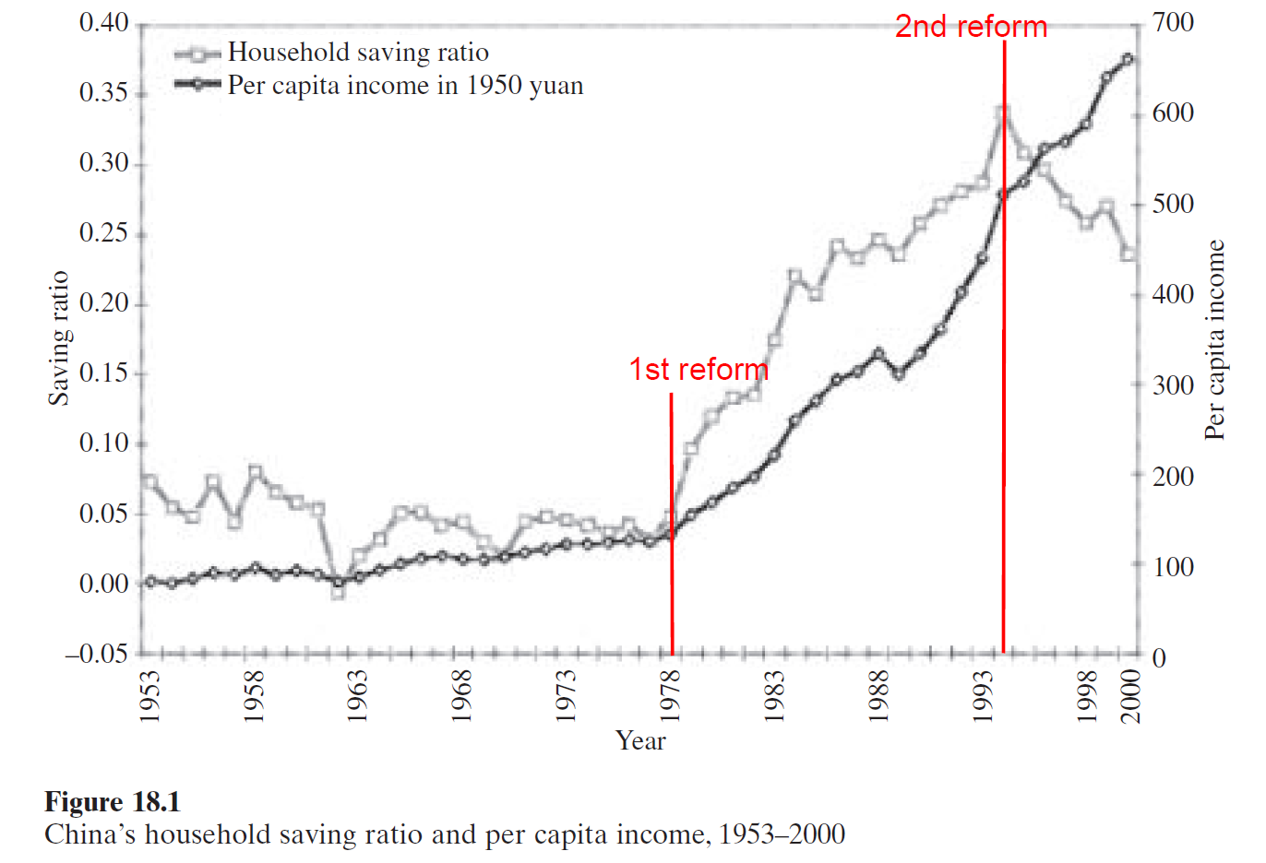
* Investment as a GDP percentage by the Chinese government has always been high
* Central government uses money for investment
* Consumption as a percentage of GDP has always been lower than other countries
* Driving force for growth is always government investment dependent, even to today
* Money for investment used to come from SOEs during government control. SOE profits transferred to government which used the money for investment
* After reform SOEs became uncompetitive and money losing, consequent sharp drop in government revenue since 1978
* Household savings in banks, government borrows household savings for paying for investments
* More household savings with banks and less SOE income => central government resorts to borrow money for financing its activities => central government in debt => affects fiscal responsibility => tax and corporate reforms
* Second fiscal reform largely replaced the traditional revenue remittance system with a tax system
* Central government comes from corporate tax, personal tax, VAT 17, corporate profit tax 33%, consumption tax:cigarette, alcohol
* Effective decentralization requires (a) accountability of local government, (b) autonomy of local government operation, (c) clarity and transparency of central government mandates and entitlements given to local government, and (d) capacity of local government to collect revenues and deliver services efficiently, combined with central government capacity to monitor and audit.
* **Factor for instability:** SOEs become non-competitive resulting in government inability to execute fiscal policies
* Government spends about 30% of all income
* Final local government revenue is 70% of total revenue. Central government percentage of total revenue is 30%
* **Factor for instability:** Centralization and decentralization of authority and revenue collection process
* Causes of instability:
  + economic reform,
  + high savings high investments, and growth rate which later turns into non-performing debt(controlling the ratio of investment to the economy)
  + bank dominated financial sector(operate for their own benefit, don’t care about financial stability: make sure commercial banks operate in interest of the full economy)
  + huge money stock: Financial banks have a lot of money to lend especially to non-performing projects (monetary policy: central bank(People’s Bank of China=US FED) must control commercial bank liquidity, control inflation)
* The objective of the Chinese monetary policy is three-fold: to maintain sustainable growth rather than short-term economic performance; to maintain price stability; and to maintain the stability of the financial system
* Control over the credit growth
* Government bonds
* New financing through trusts and wealth management products
* Central bank uses interest rates to control borrowing costs and therefore the financing of projects for investments
* Nonperforming Loans in the banking sector
* Commercial bank will go bankrupt, remedy: to be decided
* Future instability factor: still very low, hot money financial crisis, implies remedy for financial crisis
* Forthcoming instability factor:
* Fast wage increase in China implies high potential of inflation: Remedy to be decided

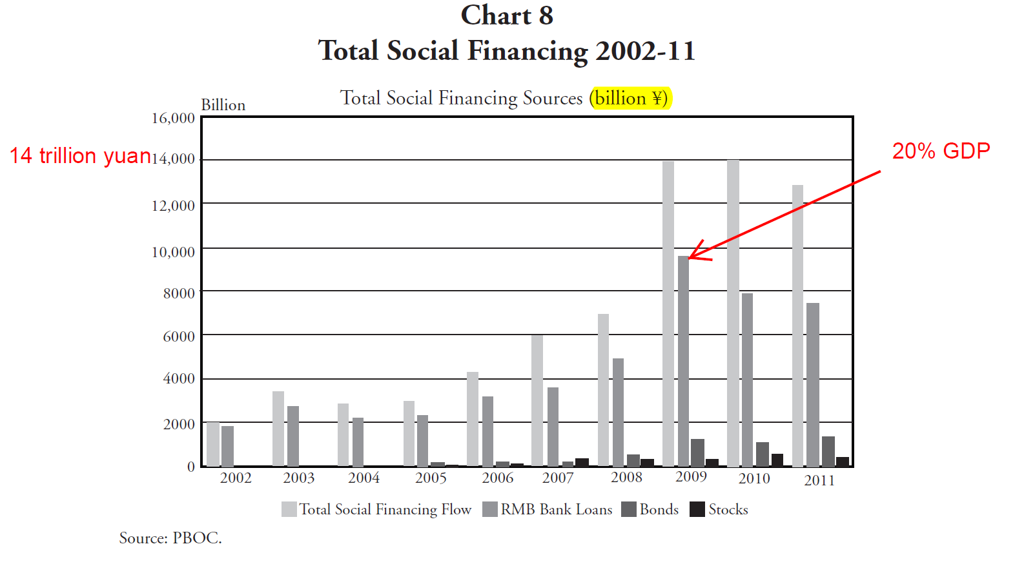

* Slide 1: Background and features of economic growth
  + Growth pushed by investment
  + 1978-2010 Correlation between GDP growth rate and inflation rate
  + Fiscal Policy is very effective in boosting economic growth and overcoming inflation/deflation
* First, China’s growth in the past two decades is mainly driven by investment. The increase in the growth rate of investment normally will persist until serious overheating occurs. The overheating develops in two stages: GDP grows at a rate higher than potential growth rate first and then inflation worsens.
* Whenever the growth rate of GDP surpasses the potential growth rate, inflation would rise at an accelerating pace several quarters later. Whenever GDP growth slows, inflation will fall with similar time lags.
* However, because the availability of credit is the most important prerequisite to investment growth and hence GDP growth, in some extreme circumstances, despite side effects, targeting credit and using “moral persuasion” to achieve the credit target is more effective than control through money supply.
* Fiscal policy is very effective in boosting economic growth and overcoming deflation
* China’s M2-to-GDP ratio has reached 180 percent, the highest among major economies in the world. This extremely high degree of monetization of the economy implies that it will become increasingly difficult for the PBOC to control the liquidity of the economy via changes in money supply.